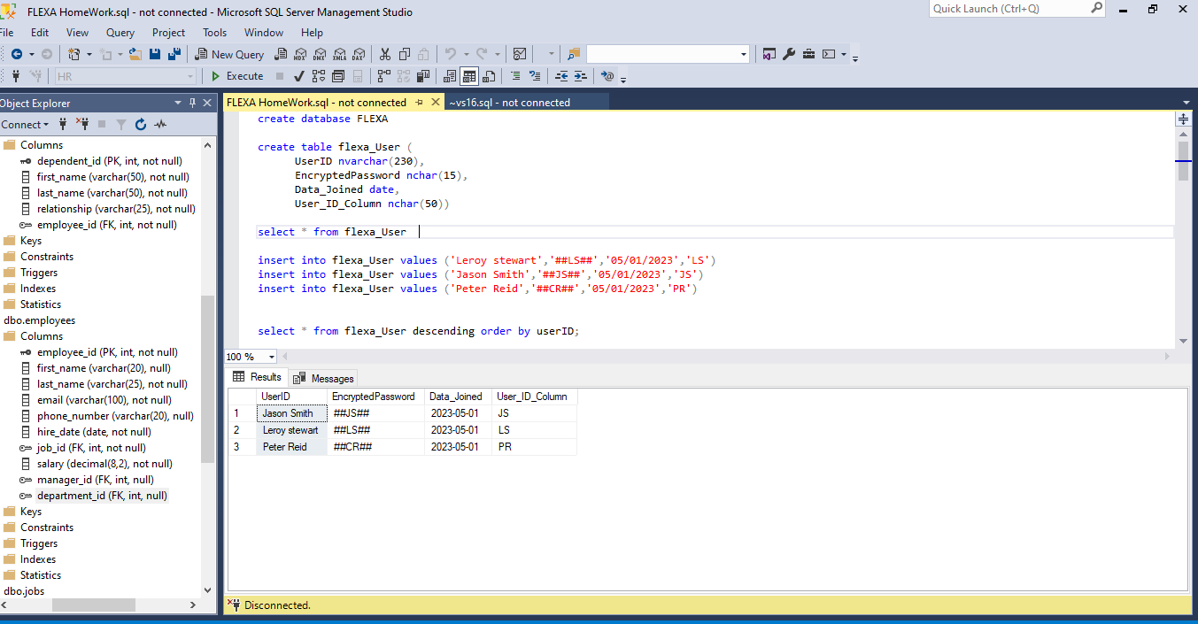

**Creating a Data Base. | Creating a Table. | Inserting Data into the Table.**

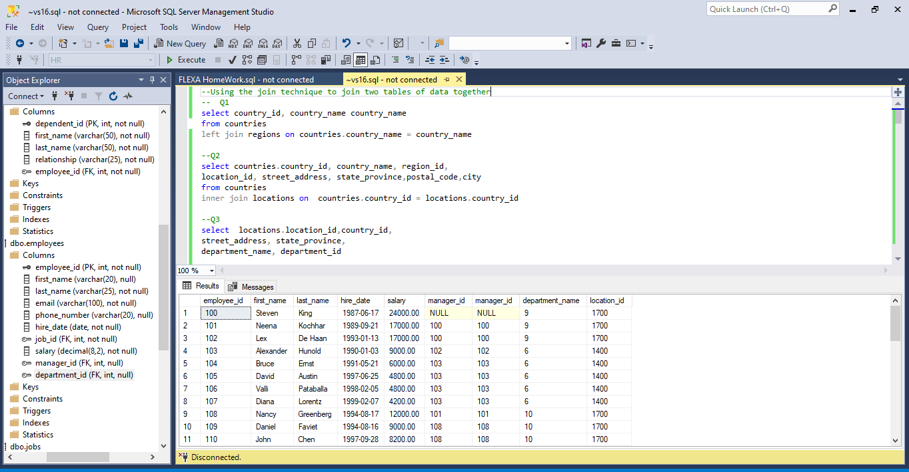

**Using the join function to merge two tables of Data together.**